# ENSF 592 Group 2 Final Report

## Running our program

First and foremost, it should be noted that our project is run using the file **main_program.py,** and all screenshots for the program are found in the **screenshots** folder.

## Background on Fantasy Football

The overarching purpose of this project is to analyze fantasy football statistics. Fantasy football is a game where you are in a league of around 10 people and you draft a team of professional football players (NFL players). Everyone drafts a team which consists of 1 quarterback (QB), 2 running backs (RB), 3 wide receivers (WR), 1 tight end (TE), a “flex” position (extra WR or RB) in their starting lineup. An example of the first 7 players on a team can be seen in the following picture:

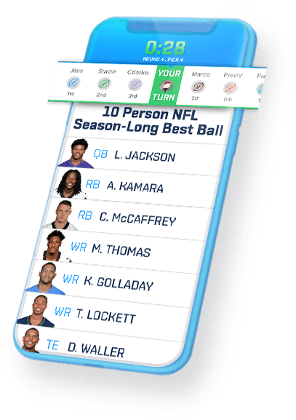

There are two main league types in fantasy football: points per reception (PPR) leagues and standard (STD) leagues. The only difference between these leagues is in PPR leagues players are allocated a point for each reception and in standard leagues no points are allocated for receptions. The scoring system for fantasy football is summarized in the following table:

|  |  |
| --- | --- |
| Category | Points |
| Passing Yards | 1 point / 25 yds |
| Passing TDs | 4 pts |
| Passing Interception | -2 point |
| Rushing Yds | 1 point / 10 yds |
| Rushing TDs | 6 pts |
| Reception | 1 point (** PPR league only **) |
| Receiving Yds | 1 point / 10 yds |
| Receiving TDs | 6 points |
| Fumbles Lost | -2 points |
| 2 Pt Conversion | 2 points |

## Description on Dataset

The dataset given contains fantasy football data for the top 300 players in 2020 based on total points, as well as the projected top 300 players in 2021 based on average draft position (ADP). The data is indexed by league type (PPR vs STD), position (WR, RB, QB, TE), and then player ID. The columns give descriptive information for each player, such as their 2020 rank, the points they scored in 2020, as well as 2021 projected points and draft position (ADP). Note that null values in this dataset arise from one of two cases:

1. Player was in the top 300 in 2020 but ranked outside of top 300 for 2021 ADP
2. Player was ranked in top 300 based on 2021 ADP but was not in the top 300 for 2020.

## Positional Specific Statistical Output

In the first part of our terminal-based application, tables are output which give insight into a specific position, for example RB. The user is asked to input the League Type, the position to study, the number of players they want to consider, and how they want to rank players. Note that for the purpose of rankings, ADP stands for Average Draft Position. After this, 3 tables are given:

1. Table of *individual statistics* for the specified number of players for the given position (ex. top 10 running backs)
2. *Overall statistics* for the specified number of players for the given position (ex. top 10 running backs)
3. Count of that position taken in the first 16 rounds of a draft (based on ADP)

## General Statistical Output

In the second part of our terminal-based application, relevant general statistics are outputted to the user. These statistics are important because they focus on relevant information a user could use going into a Fantasy Football draft. To begin, four scatter plots are created for the user. These plots compare the fantasy points per season, for the relevant top players in each position. More specifically the four plots are:

1. 2021 projected points by player in a PPR league
2. 2021 projected points by player in a STD league
3. 2020 total points by player in a PPR league
4. 2020 total points by player in a STD league

The user can use these plots to see the talent trend of each position to help them understand when to draft from what position. For example, the TE position has a huge drop off in points after the first three players. Therefore, it might be worth using a higher draft pick to get one of these three tight ends. If you are unable to get one of the three, you should wait until later in the draft to choose a TE since the rest do not have a large amount of variation in points.

Following the plots, four tables are printed in the terminal:

1. Mean 2020 ADP, Rank and Total Points by position by league.
2. Mean 2021 projected ADP and Total Points by position by league
3. Pivot table of earliest (min) 2020 draft pick of each position in each league
4. Top 10 teams with the most PPR fantasy points

The first three tables provide further, positional comparisons that could help the user while drafting. Table 4, shows team comparison for fantasy points. This could also be helpful to the user while drafting because choosing a player from a team with a large amount of projected fantasy points, brings the risk that your player could under preform due to the number of other good options on the team. However, on the reverse side, your player also has a good chance to overperform due to a strong offense producing more points that are up for grabs by their players.

Lastly, plots are created which shows a breakdown of how the top 20 Running Backs and Quarterbacks scored their points for each league.

## Project Specifications

Our solution met the specifications for this lab. We had more than three separate datasets that combined to a multi-level index data frame that was larger than 200x10. No data was hard coded and the data in the excel sheets were not modified. Three columns; Passing Pts, Rushing Pts, and Receiving Pts were added to the combined dataset. We used all of the required operations in pandas and NumPy including: describe, mean, min sum, etc. Masking, groupby and pivot table operations were all used correctly to subsets of our data. The interface provides clear guidance to the user, asks for four inputs (see Positional Specific Statistical Output) and handles any invalid input. The user is outputted several informative tables and plots. An exported excel sheet, screenshots of successful execution, this pdf description and a power point presentation can all be found in the repository. Further, all code is clearly commented and/or documented and correct syntax is used.

# Bibliography

|  |  |
| --- | --- |
| [1] | fantasydata, "Average Draft Position (ADP) 2021," 2021. [Online]. Available: https://fantasydata.com/nfl/adp. [Accessed 14 06 2021]. |
| [2] | fantasydata, "Fantasy Football Stats and Season Leaders," 2021. [Online]. Available: https://fantasydata.com/nfl/fantasy-football-leaders. [Accessed 14 06 2021]. |